# 1st

# Created on August 02 2019

# Table of Contents

1.0. home

2.0. Side Bar

3.0. login page

# 1.0. home

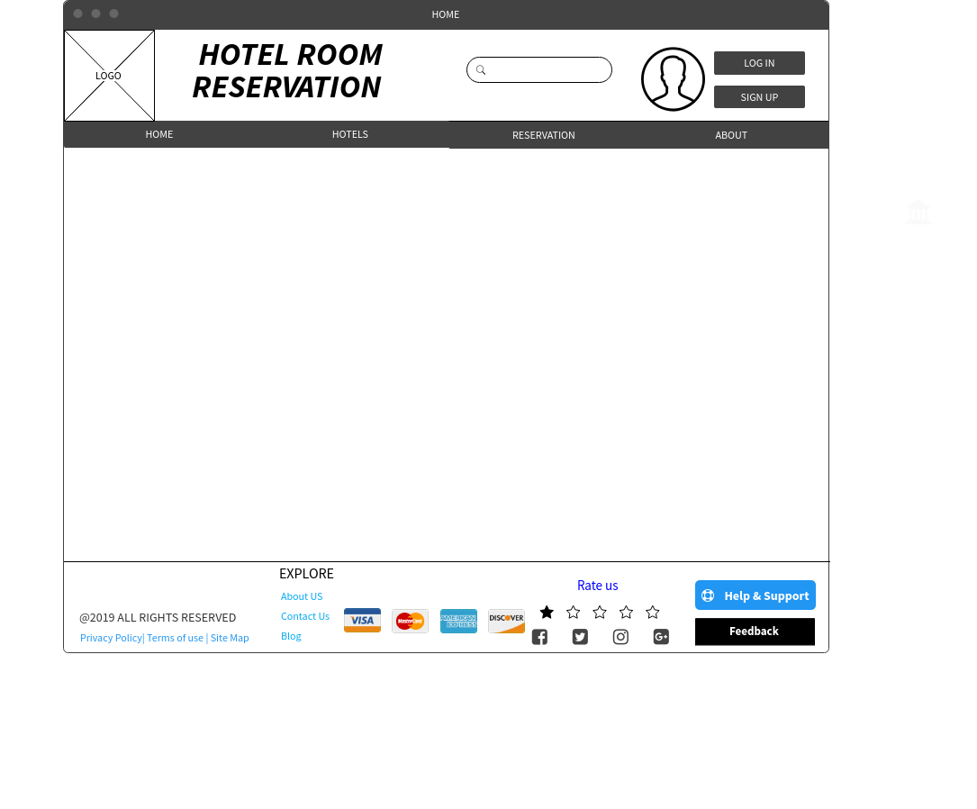

# 2.0. Side Bar

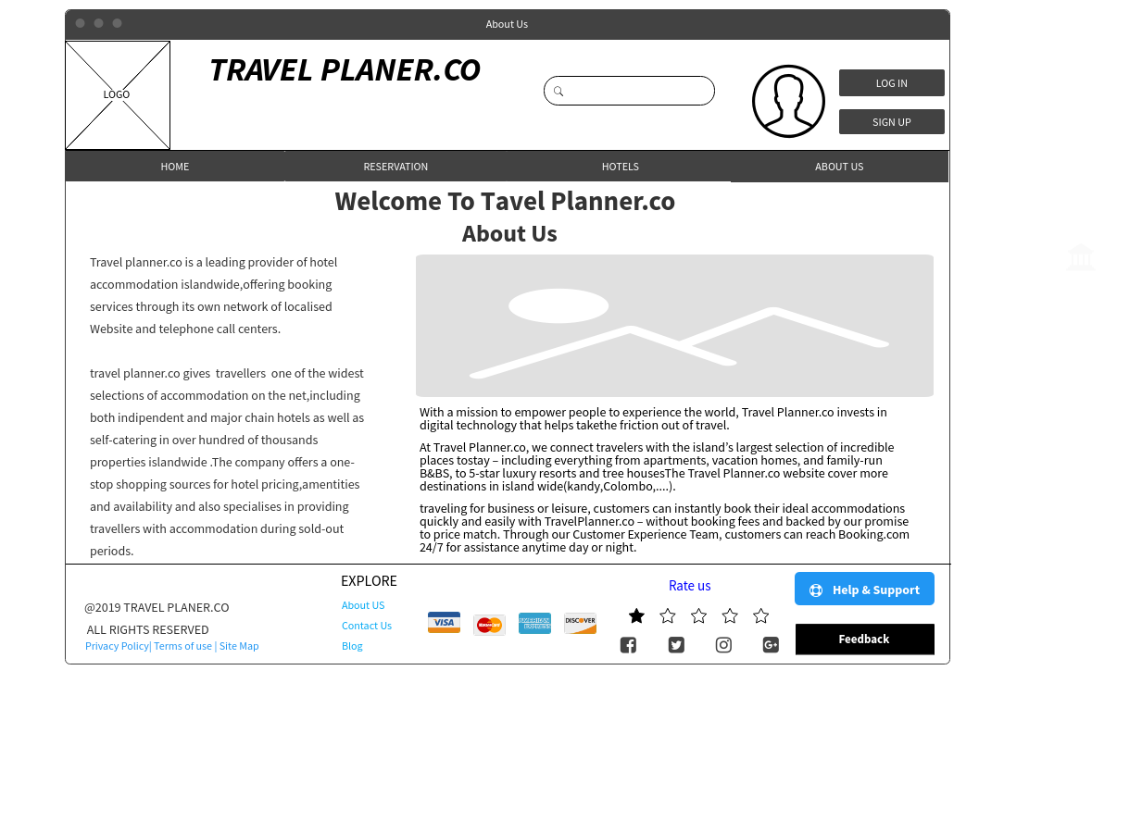

# 3.0. login page

